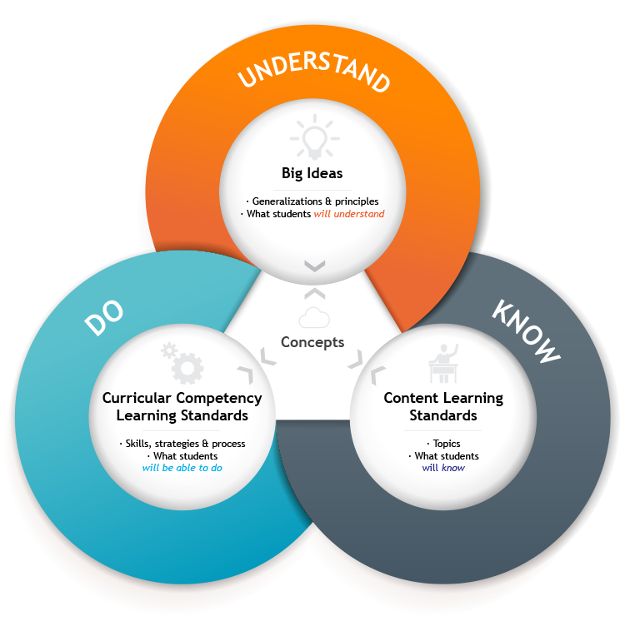
COURSE OUTLINE

Course: Physical and Health
Education 10

Teacher: Mrs. J. MacDonald
Contact Information: jenn.macdonald@sd68.bc.ca
Room: Gym
Reporting Procedure:
- Ongoing progress is available on Google Classroom (course code: xkwxjh6)
- There will be two term marks, two interim reports and a final mark for the course

Assessment:
- Will be formative and summative throughout the semester
- Physical Fitness will be monitored and measured three times during the semester, along with skill development, participation; in sport specific activities and fitness activities, and personal responsibility; understanding mental health, and healthy choices and how they impact one’s overall general health

BIG IDEAS: Students are expected to understand the following:
- Understanding our, strengths, weaknesses, and personal preferences helps us plan and achieve our goals.
- Trying a variety of physical activities can increase our chances of being active throughout our lives.
- Healthy choices influence, and are influenced by, our physical, emotional, and mental well-being.
- Personal fitness can be maintained and improved through regular participation in physical activities.
- Understanding the factors that influence our health empowers us to take action to improve it.

CURRICULAR COMPETENCIES: Students are expected to be able to do the following:
Physical literacy
- Refine and apply movement skills in a variety of physical activities and environments
- Apply and refine a variety of movement concepts and strategies in different physical activities
- Apply methods of monitoring and adjusting exertion levels in physical activity
- Demonstrate safety, fair play, and leadership in physical activities
Healthy and active living
- Participate in physical activities designed to enhance and maintain health components of fitness
- Explain how developing competencies in physical activities can increase confidence and encourage lifelong participation in physical activities
- Plan ways to overcome potential barriers that affect participation in physical activities
- Critically analyze and explain health messages and investigate their potential influences on health and well being
- Pursue personal healthy-living goals by setting goals, planning how to achieve them, and reflecting on ongoing progress
- Analyze how health-related decisions, such as those related to healthy eating, substance use, and sexual health, support the achievement of personal healthy-living goals
Social and community health
- Propose strategies for avoiding and/or responding to potentially unsafe, abusive, or exploitative situations
- Analyze strategies for responding to discrimination, stereotyping, and bullying
- Develop skills for maintaining healthy relationships and responding to interpersonal conflict, including communication skills, negotiations strategies, and conflict resolution techniques
- Critically analyze the impacts of technology and other factors on individual and community health
- Create strategies for promoting the health and well-being of the school and community
Mental well-being
- Evaluate and explain strategies for promoting mental well-being, and explore issues related to substance use
- Create and evaluate strategies for managing physical, emotional, and social changes during puberty and adolescence
- Explore and describe factors that shape personal identities, including social and cultural factors
- Describe the relationship between physical activities, mental well-being, and overall health

CONTENT: Students are expected to know the following:
- Proper technique for movement skills
- Movement concepts and strategies
- Ways to monitor and adjust physical exertion levels
- Health benefits of different physical activities
- How to participate in different types of physical activities including individual and dual activities, rhythmic activities, games and outdoor activities
- Training principles to enhance personal fitness levels, including the FITT principle, SAID principle and specificity
- Healthy sexual decision making
- Potential short- and long-term consequences of health decisions, including those involving physical activity, healthy eating, sleep routines, and technology
- Sources of health information and their trustworthiness
- Basic principles for responding to emergencies
- Strategies to protect themselves and others from potential abuse, exploitation, and harm in a variety of settings
- Consequences of bullying, stereotyping, and discrimination
- Physical, emotional, and social aspects of psychoactive substance use and potentially addictive behaviours
- Signs and symptoms of stress, anxiety, and depression
- Influences of physical, emotional, and social changes on identities and relationships
- Strategies for goal-setting and self-motivation

NOTE: some of the learning standards in the PHE curriculum address topic that some students and their parents or guardians may feel more comfortable addressing at home. Refer to ministry policy regarding opting for alternative delivery: http://www.bced.gov.bc/policy/

CORE COMPETENCIES:
Students will be accessing the Core Competencies in all their curricular areas. They may be self-assessing the Core Competencies on their Ongoing Communications. Summative reports at the end of the course will report that the student has engaged in this self-assessment.
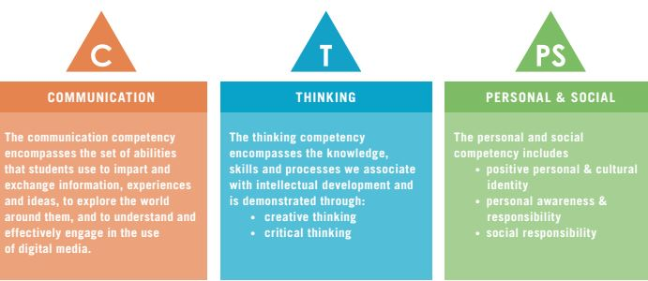
COMMUNICATION
THINKING:
CREATIVE THINKING
CRITICAL THINKING
PERSONAL AND SOCIAL RESPONSIBLITY:
POSITIVE PERSONAL AND CULTURAL IDENTITY
PERSONAL AWARENESS AND RESPONSIBILITY

PHYSICAL AND HEALTH EDUCATION EXPECTATIONS

PE Strip
Students must have PE strip for each class. Some type of running shoe is required. A comfortable shirt and shorts or yoga/track pants are acceptable. Students should be prepared to go outside on any given day, so a ‘hoodie’ or other pullover is recommended. Refer also to the student handbook on appropriate dress code for guidelines on appropriate school attire.
PE strip may be provided for students who do not provide their own. Failure to wear appropriate attire will impact a student’s grade.

Illness and Injury
Illness: It is expected that students who are well enough to come to school are well enough to take PE and to complete the vast majority of expectations within the class. Injured students should bring a note from home or a doctor if the injury is serious enough to warrant a doctor visit (normally a week or more). Students unable to participate for an extended period of time may be required to complete alternate assignments.

Security and Lockers
Day lockers are available in change rooms for the use of all students. It is strongly recommended that students purchase an extra lock from the office for $6 and use the ‘day lockers’ in the PE change rooms. Locks must be removed at the end of class. Alternately students must remember to lock valuables in their hallway locker before they come to class. Ultimately, it is the students’ responsibility to secure their valuables.

Additional Gym Facility Guidelines
PE Office: This is a staff space only; students, please stay out.
Food and Drink: Please keep all food and drink away from the gym, with the exception of bottled water.
Weight Room: Students must be supervised in this area.
End of Class: Students must remain in the gym area until the bell goes.

Parent/Guardian Information Sheet

Student name:
Student signature:
Parent/Guardian name: |  | Relationship to student:
Home Phone: |  | Cell phone:
Email:

Preferred method of contact (Please circle): Home Phone Cell Email

Other information:
Information we should know about your child’s learning with regards to Physical and Health Education?

Any other information we should know:

Parent/Guardian Signature: __________________________________________
Thank you for taking the time to fill this sheet out and return it

